2018 Annual Convention
Tinley Park Convention Center, Tinley Park, Illinois

In these pages…
Advertising and Marketing Opportunities
Page 6
Benefits
Page 2
Booth Application Form
Page 7

TO: Industry Partners of the ISVMA

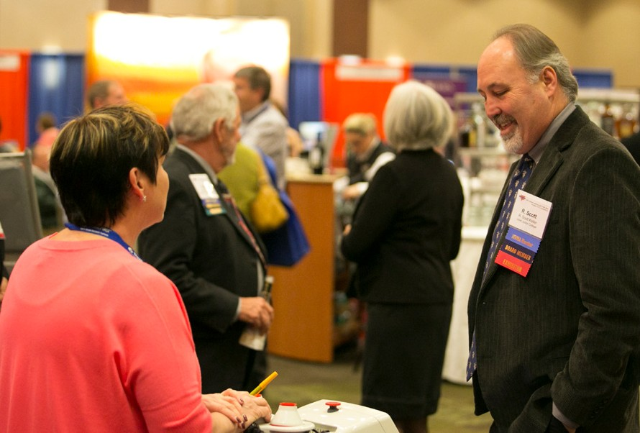
FROM: Alicia Davis-Wade
Assistant Executive Director Phone: (217) 546-8381
Fax: (217) 546-5633
alicia@isvma.org

RE: 2018 ISVMA Annual
Convention and Trade Show

Booth Information
Page 4
Cancellation Policy
Page 6
Early Bird Incentives
Page 2
Exhibitors Info
Page 8-9
Floor Plan Exhibit Hall
Page 5
Schedule
Page 3
Venue and Host Hotel
Page 2

On behalf of the ISVMA and all attendees of the 2018 ISVMA Convention, we invite you to help us provide a high-quality, highly diverse trade show for the veterinarians, certified veterinary technicians (CVTs), practice personnel and business owners who attend our meeting every year.

The ISVMA Convention is Illinois’ premier meeting for continuing education, annually supporting our veterinary professionals’ licensing requirements. Topics in business practices, companion animal, food animal, equine, exotics and a day- long track specifically for CVTs make up our event. To round out programming, the Convention includes daily wet labs and hands-on experiences. Additionally, we’ve begun offering supplemental continuing education on the trade show floor — something for everyone!

ISVMA values its relationships with our industry partners. We know you are a critical component to a successful Convention. It’s our pleasure to provide you exposure to ISVMA members at our trade show and allow an opportunity for our attendees to get to know you.

Please contact us about this tremendous opportunity to invest in the success of ISVMA, because we are committed to your success as well.

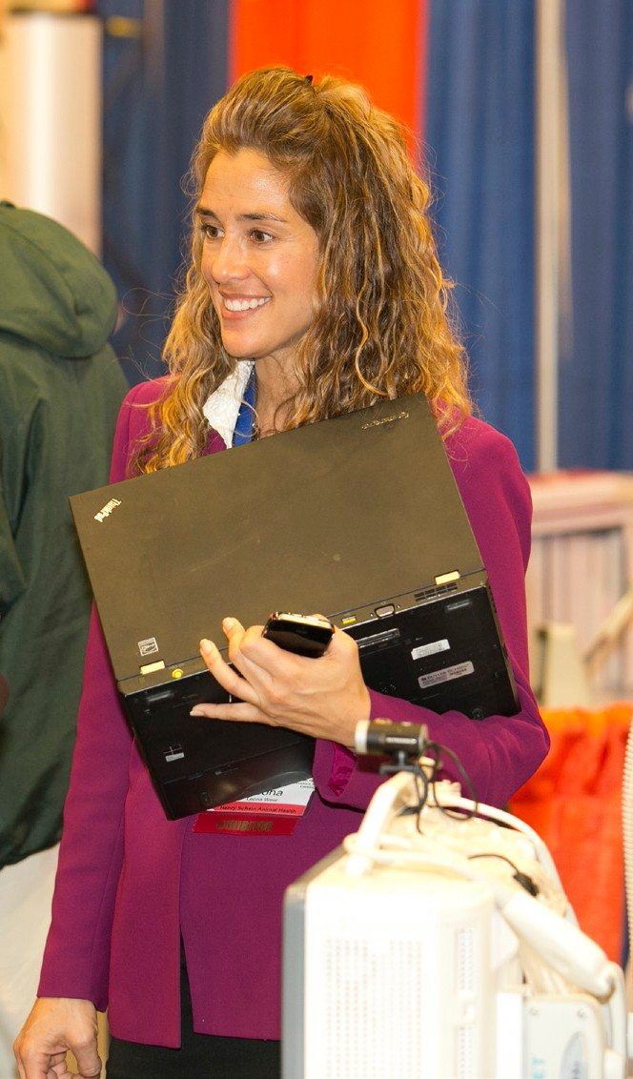

Early Bird Registration Benefits
Registrations submitted and paid by June 15, 2018, receive added benefits!
- A discounted price is offered only to those who apply and pay in full by the early bird date
- Company name appears in the Convention registration brochure reaching 4,000- plus potential registrants

Host Hotel, Trade Show and Convention Venue

Holiday Inn Hotel & Tinley Park Convention Center
18451 Convention Center Drive
Tinley Park, Illinois 60477
Group rates available through Thursday, October 18, 2018 Single/double room rate: $120 per night, plus 10 percent tax

Located just 30 miles south of downtown Chicago. Whether you prefer shopping, sight-seeing or concerts there's something for everyone all within a few short miles. Spend an afternoon shopping at the Brookside Market Place and the Orland Square Mall, stroll through historic downtown Tinley Park with its unique shopping and eateries or catch a headliner band at the Hollywood Casino Amphitheater.

Complimentary parking for registered hotel guests are available.

To reserve the special ISVMA group room rate, call the Holiday Inn directly at (844) 229-3639 and mention that you are with the ISVMA Convention. Make your reservation by Thursday, October 18, 2018, to receive the group rate.
Trade Show Benefits
- Company name listed in Convention program book with company description and contact information
- Company name listed on ISVMA’s website pre‐ and post‐Convention
- Attendee list forwarded by email to all paid exhibitors two weeks prior to event and by December 1
- Opportunity to purchase a stuffer for attendee bags
- Excellent networking opportunities

Schedule
Thursday, November 8
1-6 p.m. ................................... Exhibitor Move-In
1-6 p.m. ................................... Registration Desk Hours for Exhibitors

Friday, November 9
6-9 a.m. ................................... Exhibitor Move-In
8 a.m.-5 p.m. .......................... Registration Desk Hours for Exhibitors
9-9:30 a.m. .............................. Break in Exhibit Hall
9 a.m.-6:30 p.m. ..................... Exhibit Hall Open
3:30 p.m.-4 p.m. .................... Refreshment Break in Exhibit Hall
5-6:30 p.m. ............................. President’s Reception in the Exhibit Hall

Saturday, November 11
8 a.m.-5 p.m. .......................... Registration Desk Hours for Exhibitors
8 a.m.-4:30 p.m. .................... Convention Sessions and Wet Labs
8 a.m.-6 p.m. .......................... Exhibit Hall Hours
9-9:30 a.m. .............................. Break in Exhibit Hall (nonconflicting floor hours)
11:45 a.m.-1 p.m. .................. Lunch in Exhibit Hall (nonconflicting floor hours)
2:15-2:45 p.m. ....................... Break in Exhibit Hall (nonconflicting floor hours)
3 p.m. . . . . . . . . . . . . . . . . . . . . . . . . . . . . . . . . . . . . . . . Exhibitor Meeting in Exhibit Hall 3:45-6:30 p.m. ....................... Exhibitor Tear Down and Move‐Out
(no early tear downs)

Exhibitors Meeting
Each year, we like to meet with you, our exhibitors, to discuss your suggestions for next year’s meeting. This year, we plan to meet with you on Saturday, November 4, at 3 p.m. Bring suggestions you think will make our show better for your company.

You have the opportunity to sign up for the November 9-10, 2018, meeting, which will be held at Tinley Park Convention Center, November 9-10, 2018! If you sign up on site, you will receive 90 days of complimentary advertising on the ISVMA website!

2018 Pre-Registration
Signing up on site = discount
Complimentary web advertising = $600
Reaching over 3,000 ISVMA members = priceless

Booth Information
Booth Assignment
- Both standard and premium booth space will be assigned on a first‐ come, first‐served basis or as a benefit of sponsorship.
- Three choices for placement are requested to assist in assignment. Every effort will be made to honor those choices as well as requests for placement away from or near another exhibitor.
- Management reserves the right to make final determination of all space assignments in the best interests of the Illinois State Veterinary Medical Association (ISVMA). Management re- tains the right to refuse display space to any company whose goods and/or services are not, in the opinion of the management, compatible with the general character and objectives of the ISVMA Convention and the ISVMA.

Floor Plan Changes
The exhibitor agrees that the ISVMA Conference shall have the right to make such changes in the floor plan arrangement of booths for said exhi- bition as it shall deem necessary.

Exhibit Hall Hours
Friday
8 a.m.-6:30 p.m.

Saturday
8 a.m.-3:00 p.m.
Booth Fees
Tiered pricing
Premium booth spaces are now
available. Refer to floor layout on page 5. Legend identifies premium spaces (first-come, first‐served).
No discounts for double booth space purchases.

Early Bird Rates (before June 15, 2018)
$1,300 – Elite booth space
$1,200 – Prime booth space
$1,000 – Standard booth space

Standard Rates (after June 15, 2018)
$1,400 – Elite booth space
$1,300 – Prime booth space
$1,100 – Standard booth space

Booth Application
Applications received without payment will not be processed.

Booth Space Rental Package
- 10-foot-by-8-foot booth space
- Eight-foot back drape, three-foot draped side divider
- Six-foot skirted table
- Standard sign (7 inches by 44 inches) with company name
- Two chairs
- Two complimentary registrations to staff your booth

Exhibitor Personnel Registration Each booth includes registration for two personnel, which allows atten- dance in Convention educational sessions as well as participation
in meals and breaks served in the exhibit hall.

Booth personnel must be registered and have a Convention name badge. Individuals will not be allowed on the trade show floor without a name badge — no exceptions. Exhibitors
will be required to wear name badges to participate in educational sessions.

Additional booth personnel may register but will be assessed a fee of
$80 per person, per day. Payment permits attendance and participation in educational sessions and
meals served in the exhibit hall. Substitutions are allowed.

The exhibitor personnel registration form is on page 10 of this prospectus. October 18 is the pre‐registration deadline for booth personnel. Person- nel will be required to register on-site after this deadline.

Subject to Change
ISVMA 2018
209

210
408

407

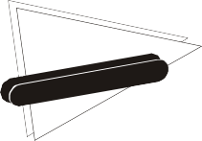
113
106
103 114
211

212

213

214

215

216
206

205

204

203

202
306 309

305 310

304 311

303 312

302 313

301 314
307 308
406

405

404

403

402

401
411

412

413

414

415
503 516
506 513
Food Area
307 308
306 | 309
305 | 310
304 | 311
303 | 312
302 | 313
301 | 314
300 315

509 | 510
508 | 511
507 | 512
506 511
Food Area
503 516
502 | 517
501 | 518
500 | 519

109 | 110
108 | 111
107 | 112
106 | 113
Food Area
103 114
102 | 115
101 | 116
100 | 117

408  407 | 409
 | 410
406 | 411
405 | 412
404 | 413
403 | 414
402 | 415
401 | 416
400 417

208 | 209  210
207
206 | 211
205 | 212
204 | 213
203 | 214
202 | 215
201 | 216
200 217

115
116
117
201
200 217
300 315
416
400 417
500
502

501

D D

J

84 - 10' x 8' Booths

c o nventio n & exp ositio n servic es

Version #1 - 11/18/15
SPRINGFIELD, IL
LO CATION
217-528-4024
FAX 217-528-4026

Elite Booth Prime Booth Standard Booth

More Ways to Be Seen
Trade Show Stuffer
Include your company‐branded item in each registrant’s tote bag (e.g., one 8.5-inch-by-11-inch flat brochure, a keychain, a letter opener, etc.). Fee may be invoiced. Your company is responsible for cost of the item and shipping to Excel Decorators for dray- age. Request 1,000 items.

Cost to purchase: $250

Participation deadline:
Monday, October 8, 2018

Convention Program Book Advertising
Include a half‐page horizontal display ad in our Convention program book. Fee may be invoiced.

Technical specifications
- File format: JPG, PDF or EPS
- File resolution: high-resolution (300 dpi or higher)
- Ad dimension: 7.5 inches wide by 5 inches
- Design restrictions: full‐color op- tion, screens accepted, no bleed

Cost to purchase: $500
(still at 2011 rates!)

Participation deadline:
Tuesday, September 4, 2018

Cancellation Policy
(Must be received in writing)
- Full refund (less $50 processing fee) prior to September 4, 2018
- 50 percent refund from September 5 to September 30, 2018
- No refund after October 1, 2018

Important Printing Deadline
September 5, 2018
On September 5, 2018, all display ad artwork, logos and company descriptions for the Convention program book must be received by the ISVMA for inclusion. A booth appli- cation received after this date may not have its company included in the Convention program book distributed on- site for all registered attendees.

Sponsorship Opportunities
There are several sponsorship opportunities available for this year’s conference. If
you would like to support the ISVMA and have your company recognized for your contribution, call Dr. Michelle
Gundlach for additional details at (217) 546-8381 or michelle@ isvma.org. You can sponsor anything from breaks to lunch to tote bags. If you prefer, you can be a cash sponsor. Your support is welcomed and very much appreciated!

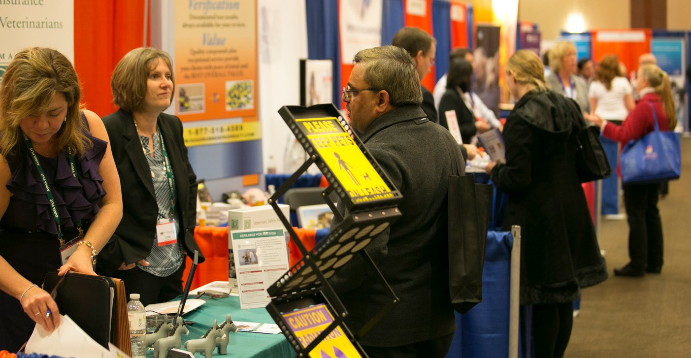

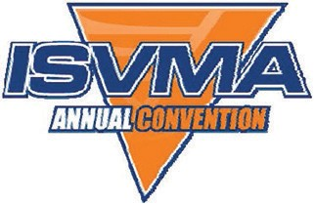
2018 Annual Convention and Trade Show

Friday, November 9, and Saturday, November 10 Tinley Park Convention Center
Exhibit Booth Application
Illinois State Veterinary Medical Association 1121 Chatham Road, Springfield IL 62704
Phone: (217) 546-8381 | Fax: (217) 546-5633

Tiered Pricing for Booth
No discounts for double booth space purchases. Early bird pricing available! Take advantage and save.

Booth Size: 10 feet by 8 feet

Booth Fees

alicia@isvma.org

Company Name (as it will appear in Convention materials):

Corporate Contact Person (for billing purposes)
Before June 15, 2018
$1,300 – Elite booth space
$1,200 – Premium booth space
$1,000 – Standard booth space

Booth Selection
After June 15, 2018
$1,400 – Elite booth space
$1,300 – Premium booth space
$1,100 – Standard booth space

Name: Title: Email: Phone: Fax: Mailing Address: City/State/ZIP:
Regional and/or On-Site Contact Person (to receive information on booth assignment, personnel registration, exhibitor’s manual, partici- pation deadlines and reminders)
Name: Title: Email: Phone: Fax: Mailing Address: City/State/ZIP:
Important Printing Deadline: September 5, 2018 On September 5, 2018 all display ad artwork, logos and com- pany descriptions for the Convention program book must
be received by the ISVMA for inclusion. A booth application received after this date may not have its company included in the Convention program book distributed on-site to all registered attendees.
First choice: Second choice: Third choice:

Every effort will be made to assign space in the order of your choice, providing the space is available. In assigning space, care is taken to not place competing suppliers nearby when possible. In order to assist us in assigning booth space, please list those competitors you would prefer not to be near.
1.
2.
3.

Method of Payment

By check
  - Make check payable to ISVMA, and forward completed form by mail to ISVMA, 1121 Chatham Road, Springfield, IL 62704.
  - Payment in the amount of $ enclosed with application

By credit card
Forward completed form by fax to (217) 546-5633, email to alicia@ isvma.org or mail to ISVMA, 1121 Chatham Road, Springfield, IL 62704.
Visa MasterCard

Remit for payment the amount of $ to my credit card payable upon receipt.

Cancellation Policy
(Must be received in writing)
- Full refund (less $50 processing fee) prior to September 4, 2018
- 50 percent refund from September 5 to September 30, 2018
- No refund after October 1, 2018

I am authorized by my company to contract for exhibit space at the ISVMA Convention to be held in Lombard, Illinois, on November 9-10, 2018. By signing and dating the contract, the exhibitor agrees to the terms of payment specified on this contract and the rules and regulations outlined on page 8.. Registration is not complete until payment is complete.

Cardholder’s Name:

Account Number: Expiration Date: V‐Code:
Authorized Signature Date

Rules and Regulations for Exhibitors

These rules and regulations governing the ISVMA Annual Convention and Trade Show are part of the exhibit contract. The inter- pretation and enforcement of the rules and regulations by Convention management are final. All matters not specifically covered by these rules and regulations are subject to the decision of Convention management. Convention management is defined as the ISVMA executive director and ISVMA staff.

Use of Exhibit Space
All demonstrations and distributions of circulars and promotional material must be confined to the limits of the exhibitor’s booth. No exhibitor shall assign, sublet or share the space assigned without the prior consent of ISVMA. Exhibitors must feature products and services of their regular course of business, unless otherwise approved by ISVMA. Exhibits that include the operation of musical equipment, radios, sound/motion picture equipment, public address systems or any sound‐mak- ing device must be operated so that the volume will not annoy or disturb adjacent exhibitors and their patrons, and must be approved by ISVMA, said approval to be
at the sole discretion of ISVMA. Exhibitors are required to have their exhibit space neat and orderly at all times. Judgments concerning these matters are the sole discretion of ISVMA. Installation, operation and removal of exhibits shall be done without causing undue interference with other exhibitors, visitors or other indi- viduals entitled to be in the exhibit area. Judgments concerning these matters are the sole discretion of the ISVMA.

Liability
The exhibitor hereby agrees to and does indemnify and hold harmless and defend ISVMA, Westin Lombard Yorktown Center, Lombard, Illinois, their officers, agents and employees from and against damage, cost or expense of any kind whatsoever (including but not limited to cost, interest and attorney’s fees), which ISVMA or
the Westin Lombard Yorktown Center, Lombard, Illinois, may incur, suffer, but put to, pay, or be required to pay incident to or arising directly or indirectly from any intentional negligent act or omission by an exhibitor or any of its employees, ser- vants or agents, subject to the provisions herein. The exhibitor further agrees that
ISVMA, its officers, agents and employees shall not be responsible in any way for (i) damage, loss, or destruction of property of exhibitors or (ii) injury to exhibitor or its representatives, agents, employees, licens- ees or invitees. The exhibitor agrees to and does indemnify, hold harmless and defend ISVMA, its officers, agents and employees from any claims arising out of damage, loss or destruction under (i) or (ii) herein.

Inability to Hold Show
If, because of war, fire, strike, exhibit facility construction or renovation project, govern- ment regulation, public catastrophe, act of God or the public enemy, or other cause beyond the control of ISVMA, the Confer- ence or any part thereof is prevented from being held or is cancelled by ISVMA, or the exhibit space becomes unavailable, ISVMA shall determine and refund the exhibitor its proportionate share of the balance of the aggregate exhibit fees received that remains after deducting expenses incurred by ISVMA and reasonable compensation to ISVMA, but in no case shall the amount of refund to the exhibitor exceed the amount of exhibit fee paid. ISVMA shall not have other further liability to exhibitor. The exhibitor may consider obtaining appro- priate insurance coverage at its cost and expense for this contingency. ISVMA does not furnish same directly or indirectly.

Repairs and Damages
Exhibitors are liable for any damage caused by fastening displays or fixtures to the building floors, walls or standard booth equipment, or for damage caused in any manner. Exhibitors may not apply paint, lacquer, adhesive or any coating to
the building walls and floor or to standard booth equipment.

Public Aisles
Public aisles may not be used by exhib- itor under any circumstances as man- dated by the local fire code. Business on the trade show floor must be conducted within the booth.

Security
Security will be provided for no additional fee. The duty of the guards will be to protect the general exhibit area against fire or other catastrophes. Neither the ISVMA nor the Westin Lombard Yorktown Center, Lombard,
Illinois, assumes any responsibility for exhibi- tors’ personal property or theft of such.

Accessibility
Exhibitor will ensure that its display is accessible to visitors who use wheelchairs or who have other disabilities.

Animals
Animals in the exhibit hall will require prior authorization. Exhibitors must submit a written request to Convention management. This includes animals used for demonstration purposes.

Foodservice
The ISVMA’s agreement with the Westin Lombard Yorktown Center prohibits food or beverage from outside sources being brought into the exhibit booths unless contracted with catering. The exhibitor understands and accepts these terms as contracted obligations with the caterer and ISVMA Convention.

Fire and Safety
All display materials must be flameproof and subject to inspection by the local fire department. No flammable fluids or sub- stances may be used or shown in booths. If inspection indicated that an exhibitor has neglected to comply with these regulations or otherwise incurs fire hazards, the right
is reserved to cancel all or such part of an exhibit as may be irregular. Exhibitors shall comply with all local fire regulations.

Insurance
The exhibitor shall, at its sole cost and expense, procure and maintain throughout the term of the contract for exhibit space comprehensive general liability insurance against claims for bodily damage or death and property damage occurring in or upon resulting from the premises leased. The exhibitor shall, at its sole cost and expense, procure and maintain throughout the term of this contract workers’ compensation
and occupational disease insurance in full compliance with all federal and state laws covering all exhibitor’s employees engaged in the performance or any work for the exhibitor. All property of the exhibitor is understood to remain under its custody and control in transit to, within and in tran- sit from the confines of the exhibit hall.

EXHIBI ORS
T

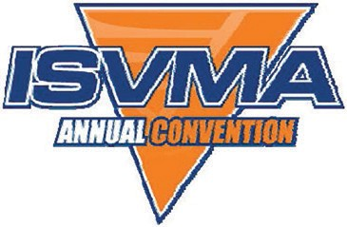
ISVMA 136th Annual Convention

November 9-10, 2018 – Tinley Park, Illinois

Information

Installation and Move‐In Thursday, November 8, 2018, 1-6 p.m. Children under the age of 18 are not allowed in the exhibit hall during in- stallation and dismantling of exhibits. Move‐in ends at 6 p.m. on Thursday to allow time to clean and clear the exhibit hall before the opening of the trade show.

Dismantling and Tear Down

Saturday, November 10, 2018, 3:00-
4:30 p.m.
Exhibitors must not tear down or pack prior to the close of the trade show on Saturday, November 10 at 3-4:30 p.m. All displays must be evacuated by 4:30 p.m. Shipping arrangements should be completed
with the official Convention decorator.
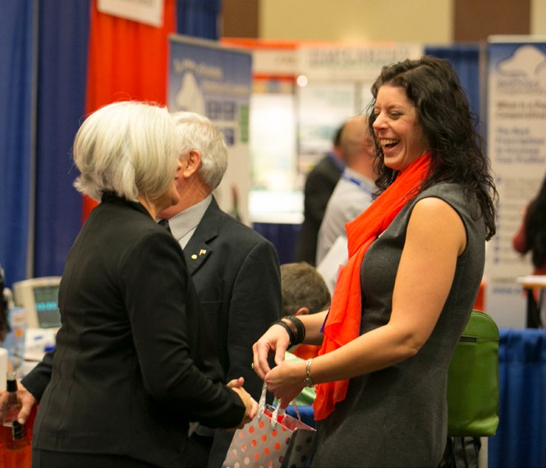
Materials remaining in the exhibit hall after 4:30 p.m. on Saturday, November 10, will be removed at the exhibitor’s expense.

Show Decorators Excel Decorators, Inc. 3600 Winchester Rd.
Springfield, IL 62707
(217) 528-4024
www.exceldecorators.com

Decorating Services
All services customarily required by exhibitors are available through Excel Decorators, Inc. (Ex- cel). Order forms for services will be available through Excel and forwarded in the exhibitor service kit. The service kit will be online six weeks prior to the event.
Acceptance of exhibit space by an exhibitor will constitute agree- ment to use only Excel Decorators, Inc. Exhibitors may not use an independent contractor.

Drayage/Shipping
It is the exhibitor’s responsibility to pre‐arrange shipping/drayage with Excel. The exhibitor service kit will include shipping information and rates. Questions should be directed to Excel. Direct shipment

of booth to the Westin Lombard Yorktown Center, Lombard, Illinois, will not be accepted and may be returned. Storage is not available on-site for exhibitors to ship direct- ly to Westin Lombard Yorktown Center, Lombard, Illinois. ISVMA will not accept any responsibility for items shipped directly to the Westin Lombard Yorktown Center, Lombard, Illinois.

Flooring/Carpet
The exhibit hall is carpeted. Excel Decorators offers additional car- pet rental, if desired.

Electric and Internet
Electric and Internet services are provided to confirmed exhibitors by the Westin Lombard Yorktown Center, Lombard, Illinois. The form to order these services can be found online six weeks prior to the event through Excel’s website.

Services
www.exceldecorators.com

ISVMA 136th Annual Convention | 9

2018 Annual Convention and Trade Show – Booth Personnel Registration

Company name: Additional Registrant – $80 per person, per day
Full Name (as it will appear on name badge):
First Registrant (included with booth fee)

Full Name (as it will appear on name badge):

Mailing Address: City/State/ZIP: Email: Phone: Fax:

Are you interested in earning continuing-education credits?
  - Yes  No

What title/position do you hold?
  - DVM  CVT  Industry Professional
Which day(s) will you attend?  Friday  Saturday Do you have dietary restrictions?
  - Gluten-free  Diabetic  Vegetarian

Second Registrant (included with booth fee)
Full Name (as it will appear on name badge):

Mailing Address: City/State/ZIP: Email: Phone: Fax:

Are you interested in earning continuing-education credits?
  - Yes  No

What title/position do you hold?
  - DVM  CVT  Industry Professional
Which day(s) will you attend?  Friday  Saturday Do you have dietary restrictions?
  - Gluten-free  Diabetic  Vegetarian

Complete for all additional personnel
I am authorized to contract for booth personnel at the 2017 ISVMA Convention, Lombard, Illinois, November 3-4, 2017.
Mailing Address: City/State/ZIP: Email: Phone:

Are you interested in earning continuing-education credits?
- Yes  No

What title/position do you hold?
- DVM  CVT  Industry Professional
Which day(s) will you attend?  Friday  Saturday Do you have dietary restrictions?
- Gluten-free  Diabetic  Vegetarian

Are you splitting a shift with a coworker?  Yes  No
If yes, name of coworker:

Additional Registrant– $80 per person, per day
Full Name (as it will appear on name badge):

Mailing Address: City/State/ZIP: Email: Phone:
Are you interested in earning continuing-education credits?
- Yes  No

What title/position do you hold?
- DVM  CVT  Industry Professional
Which day(s) will you attend?  Friday  Saturday Do you have dietary restrictions?
- Gluten-free  Diabetic  Vegetarian

Are you splitting a shift with a coworker?  Yes  No
If yes, name of coworker:

Method of Payment

By check
Make check payable to ISVMA and forward completed form by mail to ISVMA, 1121 Chatham Road, Springfield, IL 62704.

By credit card
Forward completed form by fax to (217) 546-5633, email to alicia@ isvma.org or mail to ISVMA, 1121 Chatham Road, Springfield, IL 62704.
Visa MasterCard
Cardholder’s name: Account number: Expiration date: V‐code:
Illinois State Veterinary Medical Association Fax: (217) 546‐5633
alicia@isvma.org

Registration is not complete and will not be processed until payment in full is received.

