140TH ISVMA Annual Convention: In-Person Event!!!
November 4-6, 2022
This is the CE Convention Planned by Veterinary Professionals for Veterinary Professionals
ISVMA is pleased to announce the 140th ISVMA Annual Convention will be live November 4-6, 2022 at a new location, the Hilton Chicago/Oak Brook Hills Resort & Conference Center in Oak Brook, IL.

Featured Speakers

Communication with Clients in Difficult Situations
ISVMA is excited to have Second City Alum Lisa Linke, MBA, MA, who is an actor, writer, improviser and produce, presenting tow communication workshops aimed at dealing with difficult clients on Saturday November 5, 2022.
Workshop description:
The pandemic has made communication much more difficult. Phone conversations, masked conversations, and increased stress overall for everyone often makes for difficult communication. How do you respond when a client becomes angry? What do you say? Does their anger increase your anxiety?
In this experiential workshop, participants will discuss the following concepts: Mindset, Listening and “Yes, And”, and how they apply to challenging conversations. As they work in pairs and trios to practice these concepts, they will debrief as a large group their experiences and how their insights can apply to high-stakes conversations.
You are already the expert of your communication style: this workshop is an opportunity to try on some new skills and approaches in a low-stakes environment and see how they fit for your use, both internal to your practice and externally with clients.
SESSION CONTENT WARNING: You will giggle, perhaps even laugh. You’ll most likely enjoy parts of this workshop or the whole enchilada. You are the expert of you, and while you are not required to share your insights, anything you choose to share will be welcomed and appreciated by the facilitator and other participants.

ISVMA would like to highlight ISVMA member Mark Howes, DVM, DACVR who will speaking on Saturday November 5, 2022. Dr. Howes is sponsored by the by Universal Imaging.

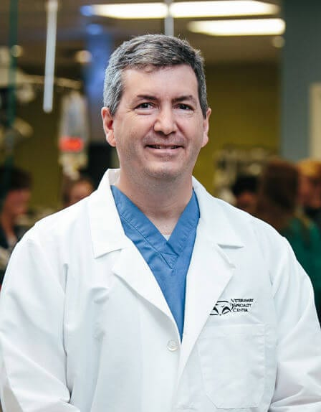
Dr. Mark Howes grew up in Oregon, IL, where he started working with his father, a mixed animal practitioner, at a very young age. Watching his father perform every imaginable veterinary task throughout the countryside of Ogle County solidified the goal of following in those footsteps.
After finishing veterinary school at Iowa State University, Mark began a long journey to board certification as a veterinary radiologist. The first step was a blend of general practice and emergency medicine in the Chicago’s northwest suburbs. He then purchased Berglund Animal Hospital in Evanston where his true passion evolved when he purchased the practice’s first ultrasound machine. The ability to see inside the patient in real time had an enormous impact on Mark’s goal for the future.

After 21 years as a general practitioner, a very fortunate series of events allowed Mark to enter a
Diagnostic Imaging residency at the University of Illinois under the supervision of Dr. Bob O’Brien.

After finishing his residency, Dr. Howes was offered a position at Veterinary Specialty Center in Buffalo
Grove where he joined without hesitation.

He has lectured and led ultrasound laboratories for technicians and veterinarians from around the country at various regional and national meetings.

Saturday, Nov. 5, Mark Howes, DVM, DACVR
Sponsored by: Universal Imaging
8:00 am – 8:50 am Thoracic and Abdominal Radiographs
These first 2 case-based lectures will simplify the interpretation process and exam the criteria for reading various radiographs. These lectures will incorporate tips that can be used on a daily basis. The cases will include thoracic radiographs (including the heart, lungs, mediastinum and thoracic wall) and abdominal radiographs. Lung patterns will be reviewed, with emphasis on prioritization of the differential diagnostic list and next diagnostic steps. Included in these cases will be some unusual or newly described conditions.

9:00 am – 9:50 am Thoracic and Abdominal Radiographs – Continued
10:30 am – 11:20 am A Focused Look at Ultrasound
The right side of the abdomen will be examined with the ultrasound. There is a lot of information tucked under the right costal arches. Tips and tricks to examine this very important region will be discussed. We'll also touch on what to do when we find something. (Hint: it involves a needle)
1:00 pm – 1:50 pm Touching on Advanced Cross-Sectional Imaging and How it Related to the General Practitioner
The use of CT/MRI is increasing for good reason. Better technology and more accurate differentials can make decisions (especially pre-operatively) easier for everybody involved. The question when to radiograph versus when to use CT/MRI will be answered. The natural follow up question will also be addressed: When do we use CT versus MRI?
2022 ISVMA Convention Speakers
Friday, November 4 Featured Speakers
Raj Naik, DVM, DACVIM (Nutrition), Topic Area: Nutrition, Sponsored by Nestle Purina
Elle De Ford, MS, PhD, DVM, MCBC, cVMA, TCCC, CCRP, Topic Rehabilitation
Michael Rosser, DVM, DACVP, MS, Topic: Cytology & a Wet Lab, Sponsored by: Banfield
Mark Mitchell, DVM, MS, PhD, DECZM Topic: Exotics, Sponsored by: Michor & ARAV
Scott Huggins, DVM, MBA, Topic: Current Trends in Practice Management & Staffing, Sponsored by: Trupanion & Blue Herron Consulting
Saturday, November 5 Featured Speakers
Lesley Smith, DVM, DACVVA Topic: Small Animal Anesthesia, Sponsored by: Akorn
Scott McClure, DVM, PhD, DACVS, DACVSMR, Topic: Equine Medicine, Sponsored by: Hilltop Biosciences
Andrea DeLoy, RVT, LVT, CVPM, Topic: OSHA Safety Programs, Sponsored by: Zoetis Animal Health
Aaron Smiley, DVM, Topic: Telemedicine, Sponsored by: Guardian Vets

Sunday, November 6, 2022
Anna McManamey, DVM, Topic: Cardiology, Sponsored by: Ceva
Bill Saxon, DVM, DACVIM, DACVECC, Topic: Diagnostics, Sponsored by: IDEXX
Patrick Roady, DVM, MS, DACVP (Anatomic), Topic: Veterinary Diagnostic Labs/Sample Submissions, Sponsored by: Illinois Farm Bureau
Caroline Tonozzi, DVM, DACVECC, Topic: Critical Care
Fred Nickle, JD & Ed Williams, JD, Topic: Protecting Your Licensure

New Location: Hilton Oak Brook Hills Resort
Please screenshot map image from this website: https://www.hilton.com/en/hotels/chibhhh-hilton-chicago-oak-brook-hills-resort-and-conference-center/hotel-location/

Also, please grab this picture of the resort: https://www.oakbrookhillsresortchicago.com/specials

Nestled in the beautiful suburb of Oak Brook, close to the breathtaking cityscape of downtown Chicago, stands the Midwest's premier golf resort and conference center. Stay in inviting accommodations overlooking the lush fairways of Willow Crest Golf Club, experience farm-to-table dining at its finest, or head over to the Monarch Spa for a rejuvenating massage - we have a myriad of extraordinary experiences to set the stage for a memorable retreat.

Hotel Amenities
Two on-site restaurants
Complimentary Self-Parking
Complimentary Wi-Fi
Concierge Service
Indoor Pool
Fitness Center
Golf Simulators
Business Center
Room Service
Easy Interstate Access
15 minutes from both O’Hare International Airport and Chicago Midway, International Airport
Minutes from Yorktown Center, which offers diverse shopping, world-class restaurants and entertainment options.

